Dharmsinh Desai University

Department of MCA

Semester -1

Web Designing

Termwork

Submitted by

Roll No : MA080

Name : Aghara Shyam Pragjibhai

**CODE**

**Index.html**

<!DOCTYPE html>

<html lang="en">

<head>

<meta charset="UTF-8">

<meta name="viewport" content="width=device-width, initial-scale=1.0">

<title>GOLF INDIA</title>

<link rel="stylesheet" href="style.css">

</head>

<body>

<div id="nav">

<img src="logo.jpg" alt="image not flound">

<h4><a style="text-decoration: none;" href="#scroller">about</a></h4>

<h4><a style="text-decoration: none;" href="becomemember.html">become

member</a></h4>

<h4><a style="text-decoration: none;" href="food.html">food</a></h4>

<h4><a style="text-decoration: none;" href="rent.html">rent</a></h4>

</div>

<video autoplay loop muted src="golfvdo.mp4"></video>

<div id="main">

<div id="page1">

<h1>EAT.DRINK.PLAY</h1>

<h2>WELCOME TO THE CITY GOLF COURSE</h2>

<p>City golf is a family golf course.you can come and have fun with family.passionate

about technology,player development</p>

</div>

<div id="page2">

<div id="scroller">

<div id="scroller-in">

<h4>TOPTRACER RANGE</h4>

<h4>GOLF LESSONS</h4>

<h4>ADVENTURE GOLF</h4>

<h4>FOOD SHOP</h4>

<h4>COFFEE</h4>

</div>

<div id="scroller-in">

<h4>TOPTRACER RANGE</h4>

<h4>GOLF LESSONS</h4>

<h4>ADVENTURE GOLF</h4>

<h4>FOOD SHOP</h4>

<h4>COFFEE</h4>

</div>

</div>

<div id="about-us">

<img src="robert-ruggiero-U5HMj5J6Opg-unsplash.jpg" alt="Image not Found">

<div id="about-us-in">

<h3>ABOUT US</h3>

<p>Welcome to our picturesque golf sanctuary, where lush fairways intertwine with

breathtaking landscapes.Join us for an unforgettable journey through an oasis

tailored for golf enthusiasts of all levels</p>

</div>

<img src="andrew-shelley-Yu6Z_Fia1Ls-unsplash.jpg" alt="Image not found">

</div>

<div id="cards-container">

<div class="card" id="card1">

<div class="overlay">

<h4>TopRacer Range</h4>

<p>An absolute gem of a course - stunning views and top-notch maintenance.

Can't wait to tee off here again!</p>

</div>

</div>

<div class="card" id="card2">

<div class="overlay">

<h4>Golf Lessons</h4>

<p>Embark on a golfing journey customized to your skill level and goals.</p>

</div>

</div>

<div class="card" id="card3">

<div class="overlay">

<h4>Adventure Golf</h4>

<p>Whether you're a local enthusiast or a visiting golfer seeking a remarkable

round, The City Golf awaits.</p>

</div>

</div>

</div>

<div id="page3">

<p>EXCELLENT COUPLE OF HOURS,RELAX AND ENJOY IN THE FUN STAFF WERE

ACCOMONDATING,FRENDLY AND VERY HELPFUL.CAFE ON SITE FOR REFRESHMENTS

ETC.WILL KEEP CHILDREN ENTERTAINED DURING THE HOLIDAYS.WORTH A VISIT IF

YOU HAVEN'T BEEN.</p>

</div>

<div id="page4">

<h1>WHAT ARE YOU WAITING FOR?</h1>

<div class="elem">

<h2>TOPTRACER RANGE</h2>

<img src="img1.jpg" alt="">

</div>

<div class="elem">

<h2>GOLF LESSONS</h2>

<img src="img2.jpg" alt="">

</div>

<div class="elem">

<h2>ADVANTURE GOLF</h2>

<img src="img3.jpg" alt="">

</div>

</div>

<div id="footer">

<div class="footer-in">

<img src="logo.jpg" alt="">

</div>

<div class="footer-in">

<h1 id="h1foo">TOPTRACER RANGE</h1>

<h1 id="h1foo">GOLF LESSONS</h1>

<h1 id="h1foo">ADVANTURE GOLF</h1>

</div>

<div class="footer-in">

<h1 id="h1foo"><a style="text-decoration: none;color: black;"

href="becomemember.html">BECOME MEMBER</a></h1>

<h1 id="h1foo"><a style="text-decoration: none;color: black;"

href="food.html">FOOD ZONE</a></h1>

<h1 id="h1foo"><a style="text-decoration: none;color: black;"

href="rent.html">RENTING</a></h1>

</div>

<div class="footer-in">

<h6>702,Royal Heightes-B,</h6>

<h6>Uma Township,</h6>

<h6>Morbi-363642,</h6>

<h6>Gujarat.</h6>

</div>

</div>

</div>

</div>

<script src="https://cdnjs.cloudflare.com/ajax/libs/gsap/3.12.2/gsap.min.js"

integrity="sha512

16esztaSRplJROstbIIdwX3N97V1+pZvV33ABoG1H2OyTttBxEGkTsoIVsiP1iaTtM8b3+hu2kB6pQ4

Clr5yug==" crossorigin="anonymous" referrerpolicy="no-referrer"></script>

<script src="https://cdnjs.cloudflare.com/ajax/libs/gsap/3.12.2/ScrollTrigger.min.js"

integrity="sha512-

Ic9xkERjyZ1xgJ5svx3y0u3xrvfT/uPkV99LBwe68xjy/mGtO+4eURHZBW2xW4SZbFrF1Tf090XqB+E

VgXnVjw==" crossorigin="anonymous" referrerpolicy="no-referrer"></script>

<script src="script.js"></script>

</body>

</html>

**style.css**

* {

margin: 0;

padding: 0;

box-sizing: border-box;

font-family: 'montserrat';

color: #fff;

}

html,body{

height: 100%;

width: 100%;

scroll-behavior: smooth;

scroll-padding:10rem;

}

#nav{

height: 145px;

width: 100%;

display: flex;

align-items: center;

padding: 0 150px;

gap: 55px;

position: fixed;

justify-content: flex-start;

z-index: 99;

}

#nav img{

height: 75px;

}

#nav h4{

text-transform: uppercase;

font-weight: 500;

}

#nav-others h4{

text-transform: uppercase;

font-weight: 500;

}

video{

height: 100%;

width: 100%;

object-fit: cover;

position: fixed;

z-index: -1;

}

#main{

position: relative;

background-color: rgba(0,0,0, 0.37);

}

#page1{

height: 100vh;

text-align: center;

width: 100%;

position: relative;

display: flex;

align-items: center;

justify-content: center;

flex-direction: column;

}

#page2{

min-height: 100vh;

width: 100%;

}

#page1 h1{

font-size: 850%;

font-weight: 900;

position: relative;

}

#page1 h1::before{

content: "EAT.DRINK.PLAY";

position: absolute;

color:#000;

top: -4px;

left: -4px;

-webkit-text-stroke: 2px #95c11e;

z-index: -1;

}

#page1 h2{

margin-top: 10px;

margin-bottom: 20px;

font-size: 195%;

font-weight: 800;

}

#page1 p{

font-size: 100%;

font-weight: 500;

width: 40%;

}

#scroller{

white-space: nowrap;

overflow-x: auto;

overflow-y: hidden;

position: relative;

z-index: 10;

}

#scroller::-webkit-scrollbar{

display: none;

}

#scroller-in{

display: inline-block;

white-space: nowrap;

animation-name: scroll;

animation-duration: 20s;

animation-timing-function: linear;

animation-iteration-count: infinite;

}

#scroller h4{

font-family: Impact, Haettenschweiler, 'Arial Narrow Bold', sans-serif;

display: inline-block;

font-size: 120px;

margin-right: 10px;

transition: all linear 0.5s;

color: transparent;

-webkit-text-stroke: 2px #95c11e;

}

#scroller h4:hover{

color:#95c11e;

}

@keyframes scroll {

from{

transform:translateX(0);

}

to{

transform: translateX(-100%);

}

}

#about-us{

height: 40vh;

width: 100%;

display: flex;

position: relative;

padding: 0 50px;

align-items: center;

justify-content: space-between;

}

#about-us img{

height: 220px;

width: 220px;

border-radius: 20px;

object-fit: cover;

}

#about-us-in{

width: 40%;

text-align: center;

}

#about-us-in h3{

font-size: 54px;

font-weight: 800;

margin-bottom: 40px;

}

#about-us-in p{

font-size: 20px;

line-height: 26px;

}

#cards-container{

height: 60vh;

display: flex;

align-items: center;

justify-content: center;

gap: 70px;

position: relative;

z-index: 10;

}

.card{

height: 80%;

width: 24%;

border-radius: 20px;

background-size: cover;

background-position: center;

overflow: hidden;

transition: all ease 0.6s;

}

#card1{

background-image: url('img1.jpg');

}

#card2{

background-image: url('img2.jpg');

}

#card3{

background-image: url('img3.jpg');

}

.overlay{

height: 100%;

width: 100%;

background-color: #95c11e;

padding: 50px;

padding-top: 30%;

opacity: 0;

transition: all ease 0.6s;

}

.overlay h4{

color: #000;

font-size: 150%;

white-space: nowrap;

text-transform: uppercase;

font-weight: 800;

}

.overlay p{

font-size: 87%;

color: #000;

}

.card:hover .overlay{

opacity: 1;

}

.card:hover{

transform: rotate3d(-1,1,0,20deg);

}

#page3{

height: 70vh;

align-items: center;

justify-content: center;

display: flex;

position: relative;

}

#page3 p{

font-size: 100%;

font-weight: 700;

width: 55%;

line-height: 170%;

text-align: center;

}

#page4{

position: relative;

height: 30vh;

width: 100%;

display: flex;

align-items: center;

justify-content: center;

gap: 70px;

}

.elem{

height: 70%;

width: 20%;

overflow: hidden;

border-radius: 20px;

position: relative;

}

.elem h2{

height: 100%;

width: 100%;

color: #000;

font-weight: 800;

background-color: #95c11e;

display: flex;

align-items: center;

justify-content: center;

position: absolute;

z-index: 10;

transition: all ease 0.5s;

}

.elem img{

height: 100%;

width: 100%;

object-fit: cover;

scale: 1.1;

transition: all ease 0.5s;

}

.elem:hover h2{

color: #fff;

background-color: transparent;

}

.elem:hover img{

scale: 1;

}

#page4 h1{

font-size: 500%;

position: absolute;

top:-15%;

font-weight: 900;

color: #000;

font-family:Impact, Haettenschweiler, 'Arial Narrow Bold', sans-serif;

-webkit-text-stroke: 1px #fff;

}

#footer{

height: 40vh;

width: 100%;

background: linear-gradient(to left bottom,#119F3A,#ACE022);

position: relative;

display: flex;

align-items: center;

justify-content: center;

gap: 70px;

}

.footer-in{

height: 50%;

width: 20%;

overflow: hidden;

position: relative;

}

.footer-in img{

height: 100%;

width: 100%;

object-fit:contain;

}

.footer-in #h1foo{

height:40px;

font-size: 120%;

font-weight:900;

color: #000;

display: flex;

align-items: center;

}

.footer-in h6{

height: 27px;

display: flex;

align-items: center;

color: #000;

z-index: 10;

}

#nav-others{

height: 110px;

width: 100%;

display: flex;

align-items: center;

padding: 0 150px;

gap: 55px;

position: fixed;

justify-content: flex-start;

z-index: 99;

background-color: #000;

}

#nav-others img{

height: 75px;

}

**script.js**

gsap.to("#nav",{

backgroundColor:"#000",

duration:0.5,

height:"120px",

scrollTrigger:{

trigger:"#nav",

scroller:"body",

// markers:true,

start:"top -10%",

end:"top -11%",

scrub:1,

}

})

gsap.to("#main",{

backgroundColor:"#000",

scrollTrigger:{

trigger:"#main",

scroller:"body",

// markers:true,

start:"top -30%",

end:"top -100%",

scrub:2,

}

})

gsap.from("#about-us img,#about-us-in",{

y:50,

opacity:0,

duration:1,

stagger:0.4,

scrollTrigger:{

trigger:"#about-us",

scroller:"body",

// markers:true,

start:"top 60%",

end:"top 55%",

}

})

gsap.from(".card",{

scale:0.8,

opacity:0,

duration:1,

scrollTrigger:{

trigger:".card",

scroller:"body",

start:"top 60%",

end:"top 55%",

scrub:2,

}

})

**becomemember.html**

<!DOCTYPE html>

<html lang="en">

<head>

<meta charset="UTF-8">

<meta name="viewport" content="width=device-width, initial-scale=1.0">

<title>BECOME MEMBER</title>

<link rel="stylesheet" type="text/css" href="becomemember.css">

<link

href="https://fonts.googleapis.com/css2?family=Montserrat:wght@400;700;800&display=swa

p" rel="stylesheet">

</head>

<body>

<div class="main">

<div class="container a-container" id="a-container">

<form class="form" id="a-form" method="post" action="index.html">

<h2 class="form_title title">Become Member</h2>

<input class="form__input" type="text" pattern="[a-zA-z]{3,15}" placeholder="Name"

name ="username" required>

<input class="form__input" type="email" placeholder="Email" name="email" required>

<input class="form__input" type="password" placeholder="Password"

name="password" required>

<button class="form__button button switch-btn" type='submit' name ="signup"

onclick="money()">SIGN UP</button>

</form>

</div>

<div class="switch" id="switch-cnt">

<div class="switch__container" id="switch-c1">

<h2 class="switch__title title">Welcome !</h2>

<p class="switch__description description">To Become Member with us please login

with your personal info</p>

<button class="switch__button button switch-btn"><a href="index.html" style="text-

decoration: none;color: white;">GO TO HOME PAGE</a></button>

</div>

</div>

</div>

<script>

function money(){

var digits = Math.floor(Math.random() * 9000000000) + 1000000000;

confirm("Member id:"+digits+'\n'+'Please Pay membership fees at counter')

}

</script>

</body>

</html>

**becomemember.css**

*, *::after, *::before {

margin: 0;

padding: 0;

box-sizing: border-box;

user-select: none;

}

body {

width: 100%;

height: 100vh;

display: flex;

justify-content: center;

align-items: center;

font-family: "Montserrat", sans-serif;

font-size: 12px;

background-color: #ecf0f3;

color: #a0a5a8;

}

.main {

position: relative;

width: 1000px;

min-width: 1000px;

min-height: 600px;

height: 600px;

padding: 25px;

background-color: #ecf0f3;

box-shadow: 10px 10px 10px #d1d9e6, -10px -10px 10px #f9f9f9;

border-radius: 12px;

overflow: hidden;

}

.container {

display: flex;

justify-content: center;

align-items: center;

position: absolute;

top: 0;

width: 600px;

height: 100%;

padding: 25px;

background-color: #ecf0f3;

transition: 1.25s;

}

.form {

display: flex;

justify-content: center;

align-items: center;

flex-direction: column;

width: 100%;

height: 100%;

}

.form__input {

width: 350px;

height: 40px;

margin: 4px 0;

padding-left: 25px;

font-size: 13px;

letter-spacing: 0.15px;

border: none;

outline: none;

font-family: "Montserrat", sans-serif;

background-color: #ecf0f3;

transition: 0.25s ease;

border-radius: 8px;

box-shadow: inset 2px 2px 4px #d1d9e6, inset -2px -2px 4px #f9f9f9;

}

.title {

font-size: 34px;

font-weight: 700;

line-height: 3;

color: #181818;

}

.description {

font-size: 14px;

letter-spacing: 0.25px;

text-align: center;

line-height: 1.6;

}

.button {

width: 180px;

height: 50px;

border-radius: 25px;

margin-top: 50px;

font-weight: 700;

font-size: 14px;

letter-spacing: 1.15px;

background-color: #4B70E2;

color: #f9f9f9;

box-shadow: 8px 8px 16px #d1d9e6, -8px -8px 16px #f9f9f9;

border: none;

outline: none;

}

.a-container {

z-index: 100;

left: calc(100% - 600px );

}

.switch {

display: flex;

justify-content: center;

align-items: center;

position: absolute;

top: 0;

left: 0;

height: 100%;

width: 400px;

padding: 50px;

z-index: 200;

transition: 1.25s;

background-color: #ecf0f3;

overflow: hidden;

box-shadow: 4px 4px 10px #d1d9e6, -4px -4px 10px #f9f9f9;

}

.switch__container {

display: flex;

justify-content: center;

align-items: center;

flex-direction: column;

position: absolute;

width: 400px;

padding: 50px 55px;

transition: 1.25s;

}

**food.html**

<!DOCTYPE html>

<html lang="en">

<head>

<meta charset="UTF-8">

<meta name="viewport" content="width=device-width, initial-scale=1.0">

<title>food order page</title>

<link rel="stylesheet" href="foodstyle.css">

</head>

<body class="">

<header>

<img src="logo.jpg" alt="image not flound">

<h4><a style="text-decoration: none;color: black;" href="index.html">home</a></h4>

<h4><a style="text-decoration: none;color: black;" href="becomemember.html">become

member</a></h4>

<h4>food</h4>

<h4><a style="text-decoration: none;color: black;" href="rent.html">rent</a></h4>

<div class="shopping">

<img src="image/shopping.svg">

<span class="quantity">0</span>

</div>

</header>

<div class="container">

<div class="list">

</div>

</div>

<div class="card">

<h1>Card</h1>

<ul class="listCard">

</ul>

<div class="checkOut">

<div class="total">0</div>

<div class="closeShopping">Close</div>

</div>

</div>

<script src="foodscript.js"></script>

</body>

</html>

**foodstyle.css**

header img{

height: 75px;

}

body{

background-color: #E3E7E8;

font-family: system-ui;

}

.container{

width: 1100px;

margin: auto;

transition: 0.5s;

}

header{

text-transform: uppercase;

display: flex;

align-items: center;

gap: 55px;

/* display: grid; */

grid-template-columns: 1fr 50px;

margin-top: 0px;

}

header .shopping{

position: relative;

}

header .shopping img{

width: 40px;

}

header .shopping span{

background: red;

border-radius: 50%;

display: flex;

justify-content: center;

align-items: center;

color: #fff;

position: absolute;

top: -5px;

left: 80%;

padding: 3px 10px;

}

.list{

display: grid;

grid-template-columns: repeat(3, 1fr);

column-gap: 20px;

row-gap: 20px;

margin-top: 50px;

}

.list .item{

text-align: center;

background-color: #DCE0E1;

padding: 20px;

box-shadow: 0 50px 50px #757676;

letter-spacing: 1px;

}

.list .item img{

width: 90%;

height: 430px;

object-fit: cover;

}

.list .item .title{

font-weight: 600;

}

.list .item .price{

margin: 10px;

}

.list .item button{

background-color: #1C1F25;

color: #fff;

width: 100%;

padding: 10px;

}

.card{

position: fixed;

top:0;

left: 100%;

width: 500px;

background-color: #453E3B;

height: 100vh;

transition: 0.5s;

}

.active .card{

left: calc(100% - 500px);

}

.active .container{

transform: translateX(-200px);

}

.card h1{

color: #E8BC0E;

font-weight: 100;

margin: 0;

padding: 0 20px;

height: 80px;

display: flex;

align-items: center;

}

.card .checkOut{

position: absolute;

bottom: 0;

width: 100%;

display: grid;

grid-template-columns: repeat(2, 1fr);

width: 100%;

}

.card .checkOut div{

background-color: #E8BC0E;

height: 70px;

display: flex;

justify-content: center;

align-items: center;

font-weight: bold;

cursor: pointer;

}

.card .checkOut div:nth-child(2){

background-color: #1C1F25;

color: #fff;

}

.listCard li{

display: grid;

grid-template-columns: 100px repeat(3, 1fr);

color: #fff;

row-gap: 10px;

}

.listCard li div{

display: flex;

justify-content: center;

align-items: center;

}

.listCard li img{

width: 90%;

}

.listCard li button{

background-color: #fff5;

border: none;

}

.listCard .count{

margin: 0 10px;

}

**foodscript.js**

let openShopping = document.querySelector('.shopping');

let closeShopping = document.querySelector('.closeShopping');

let list = document.querySelector('.list');

let listCard = document.querySelector('.listCard');

let body = document.querySelector('body');

let total = document.querySelector('.total');

let quantity = document.querySelector('.quantity');

openShopping.addEventListener('click', ()=>{

body.classList.add('active');

})

closeShopping.addEventListener('click', ()=>{

body.classList.remove('active');

})

let products = [

{

id: 1,

name: 'Samosha',

image: '1.jpg',

price: 40

},

{

id: 2,

name: 'Panir',

image: '2.jpg',

price: 200

},

{

id: 3,

name: 'Halwa Desert',

image: '3.jpg',

price: 300

},

{

id: 4,

name: 'Cold Drinks',

image: '4.jpg',

price:80

},

{

id: 5,

name: 'salad',

image: '5.PNG',

price: 150

},

{

id: 6,

name: 'Pizza',

image:'6.PNG',

price: 350

}

];

let listCards = [];

function initApp(){

products.forEach((value, key) =>{

let newDiv = document.createElement('div');

newDiv.classList.add('item');

newDiv.innerHTML = `

<img src="image/${value.image}">

<div class="title">${value.name}</div>

<div class="price">${value.price.toLocaleString()}</div>

<button onclick="addToCard(${key})">Add To Card</button>`;

list.appendChild(newDiv);

})}

initApp();

function addToCard(key){

if(listCards[key] == null){

// copy product form list to list card

listCards[key] = JSON.parse(JSON.stringify(products[key]));

listCards[key].quantity = 1;

}

reloadCard();

}

function reloadCard(){

listCard.innerHTML = '';

let count = 0;

let totalPrice = 0;

listCards.forEach((value, key)=>{

totalPrice = totalPrice + value.price;

count = count + value.quantity;

if(value != null){

let newDiv = document.createElement('li');

newDiv.innerHTML = `

<div><img src="image/${value.image}"/></div>

<div>${value.name}</div>

<div>${value.price.toLocaleString()}</div>

<div>

<button onclick="changeQuantity(${key}, ${value.quantity - 1})">-</button>

<div class="count">${value.quantity}</div>

<button onclick="changeQuantity(${key}, ${value.quantity + 1})">+</button>

</div>`;

listCard.appendChild(newDiv);

}

})

total.innerText = totalPrice.toLocaleString();

quantity.innerText = count;

}

function changeQuantity(key, quantity){

if(quantity == 0){

delete listCards[key];

}else{

listCards[key].quantity = quantity;

listCards[key].price = quantity * products[key].price;

}

reloadCard();

}

**rent.html**

<!DOCTYPE html>

<html lang="en">

<head>

<meta charset="UTF-8">

<meta name="viewport" content="width=device-width, initial-scale=1.0">

<title>Renting</title>

<link rel="stylesheet" href="rentstyle.css">

</head>

<body>

<div id="nav">

<img src="logo.jpg" alt="image not flound">

<h4><a style="text-decoration: none;color: white;" href="index.html">home</a></h4>

<h4><a style="text-decoration: none;color: white;" href="becomemember.html">become

member</a></h4>

<h4><a style="text-decoration: none;color: white;" href="food.html">food</a></h4>

<h4><a style="text-decoration: none;color: white;" href="rent.html">rent</a></h4>

</div>

<section class="popular" id="popular">

<h1 class="heading"> Buy-<span>Rent</span> Golf </h1>

<div class="box-container">

<div class="box">

<span class="price">Rs 50 per Piece</span>

<img src="golfball.jpg" alt="">

<h3>Buy Golf Balls</h3>

<button type="submit" class="ball" onclick="pay()">Buy Now</button>

</div>

<div class="box">

<span class="price">Rs 5000 per Piece</span>

<img src="golfstick.jpg" alt="">

<h3>Buy Golf Stick</h3>

<button type="submit" class="ball" onclick="pay()">Buy Now</button>

</div>

<div class="box">

<span class="price"> Rs 100 per Hour </span>

<img src="golfstick.jpg" alt="">

<h3>Rent Golf Stick</h3>

<button type="submit" class="ball" onclick="pay()">Rent Now</button>

</div>

<div class="box">

<span class="price"> Rs 1000 per Hour </span>

<img src="cartgolf.jpg" alt="">

<h3>Rent Golf Cart</h3>

<button type="submit" class="ball" onclick="pay()">Rent Now</button>

</div>

<div class="box">

<span class="price"> Rs 10000 per Hour </span>

<img src="couse.jpg" alt="">

<h3>Rent Mini GOLF course</h3>

<button type="submit" class="ball" onclick="pay()">Rent Now</button>

</div>

</div>

</section>

<section class="review" id="review">

<h1 class="heading"> our customers <span>reviews</span> </h1>

<div class="box-container">

<div class="box">

<img src="person1.jpg" alt="">

<h3>john deo</h3>

<p>This golf course is a picturesque paradise with well-groomed greens and impeccable service. A must-visit for both beginners and seasoned players!</p>

</div>

<div class="box">

<img src="person2.jpg" alt="">

<h3>Nirmal patel</h3>

<p>Stunning course layout, pristine greens, and fantastic staff make every swing here a delight. A golfer's paradise indeed!</p>

</div>

<div class="box">

<img src="person3.jpg" alt="">

<h3>RDJ</h3>

<p>An absolute gem of a course - stunning views and top-notch maintenance. Can't wait to tee off here again!</p>

</div>

</div>

</section>

<script>

function pay(){

var digits = Math.floor(Math.random() * 9000000000) + 1000000000;

confirm("Invoice No:"+digits+'\n'+'Please Pay Amount at counter')

}

</script>

</body>

</html>

**rentstyle.css**

.popular .box-container {

display:flex;

flex-wrap: wrap;

gap: 1.5rem;

}

.popular .box-container .box {

padding: 2rem;

background: #fff;

box-shadow: 0 .5rem 1rem rgba(0, 0, 0, .1);

border: .1rem solid rgba(0, 0, 0, .3);

border-radius: .5rem;

text-align: center;

flex: 1 1 30rem;

position: relative;

}

.popular .box-container .box img {

height: 25rem;

object-fit: cover;

width: 100%;

border-radius: .5rem;

}

.popular .box-container .box .price {

position: absolute;

top: 3rem;

left: 3rem;

background: var(--red);

color: #fff;

font-size: 2rem;

padding: .5rem 1rem;

border-radius: .5rem;

}

.popular .box-container .box h3 {

color: #333;

font-size: 2.5rem;

padding-top: 1rem;

}

.popular .box-container .box .stars i {

color: gold;

font-size: 1.7rem;

padding: 1rem .1rem;

}

.heading {

text-align: center;

font-size: 3.5rem;

padding: 1rem;

color: #666;

}

.heading span {

color: var(--red);

}

.review .box-container {

display: flex;

flex-wrap: wrap;

gap: 1.5rem;

}

.review .box-container .box {

text-align: center;

padding: 2rem;

border: 1rem solid #fff;

box-shadow: 0 .5rem 1rem rgba(0, 0, 0, .3);

border-radius: .5rem;

flex: 1 1 30rem;

background: #333;

margin-top: 6rem;

}

.review .box-container .box img {

height: 12rem;

width: 12rem;

border-radius: 50%;

border: 1rem solid #fff;

margin-top: -8rem;

object-fit: cover;

}

.review .box-container .box h3 {

font-size: 2.5rem;

color: #fff;

padding: .5rem 0;

}

.review .box-container .box .stars i {

font-size: 2rem;

color: var(--red);

padding: .5rem 0;

}

.review .box-container .box p {

font-size: 1.5rem;

color: #eee;

padding: 1rem 0;

}

/* CSS */

.ball {

appearance: button;

background-color: #1899D6;

border: solid transparent;

border-radius: 16px;

border-width: 0 0 4px;

box-sizing: border-box;

color : #FFFFFF;

cursor: pointer;

display: inline-block;

font-family: din-round,sans-serif;

font-size: 15px;

font-weight: 700;

letter-spacing: .8px;

line-height: 20px;

margin: 0;

outline: none;

overflow: visible;

padding: 13px 16px;

text-align: center;

text-transform: uppercase;

touch-action: manipulation;

transform: translateZ(0);

transition: filter .2s;

user-select: none;

-webkit-user-select: none;

vertical-align: middle;

white-space: nowrap;

width: 100%;

}

.ball:after {

background-clip: padding-box;

background-color: #1CB0F6;

border: solid transparent;

border-radius: 16px;

border-width: 0 0 4px;

bottom: -4px;

content: "";

left: 0;

position: absolute;

right: 0;

top: 0;

z-index: -1;

}

.ball:main,

.ball:focus {

user-select: auto;

}

.ball:hover:not(:disabled) {

filter: brightness(1.1);

-webkit-filter: brightness(1.1);

}

.ball:disabled {

cursor: auto;

}

.ball:active {

border-width: 4px 0 0;

background: none;

}

#nav{

height: 110px;

width: 100%;

display:flex;

align-items: center;

padding: 0 150px;

gap: 55px;

position: relative;

justify-content: flex-start;

z-index: 99;

font-family: 'montserrat';

background-color: #000;

}

#nav img{

height: 75px;

}

**OUTPUT**

Home page

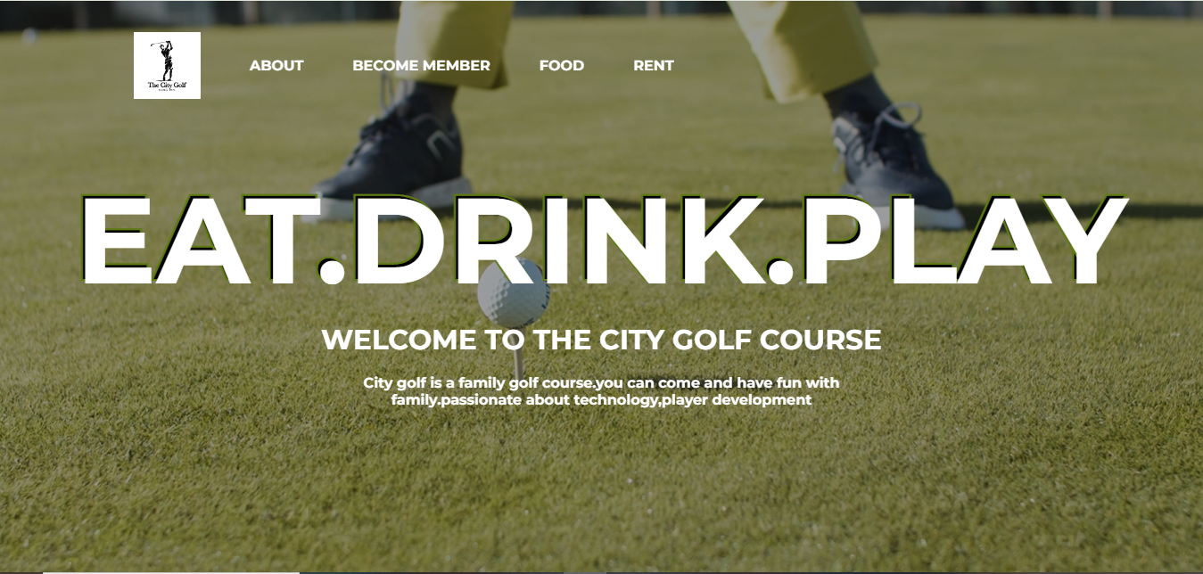

About



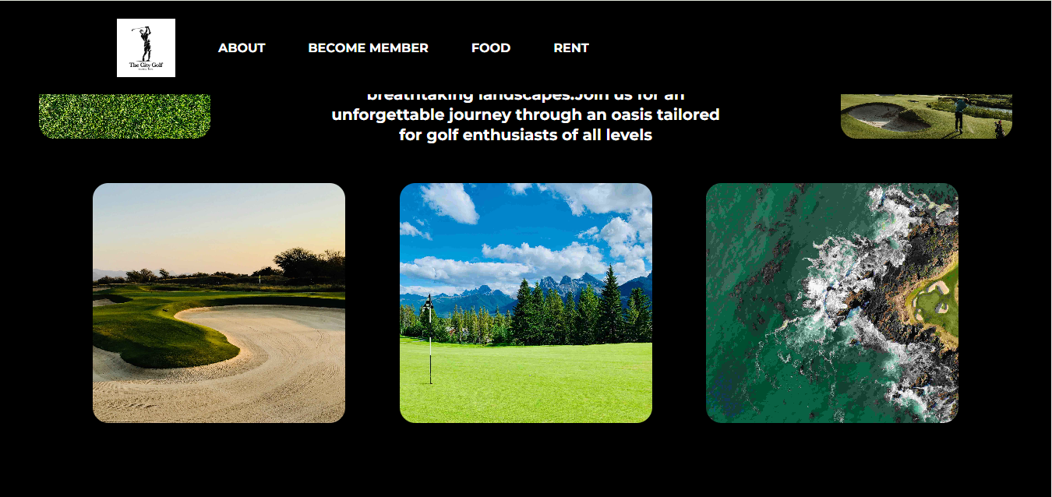

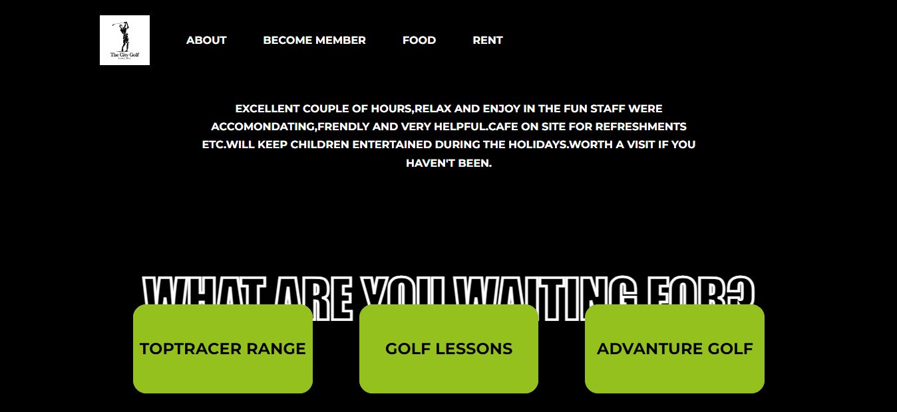

Become member page

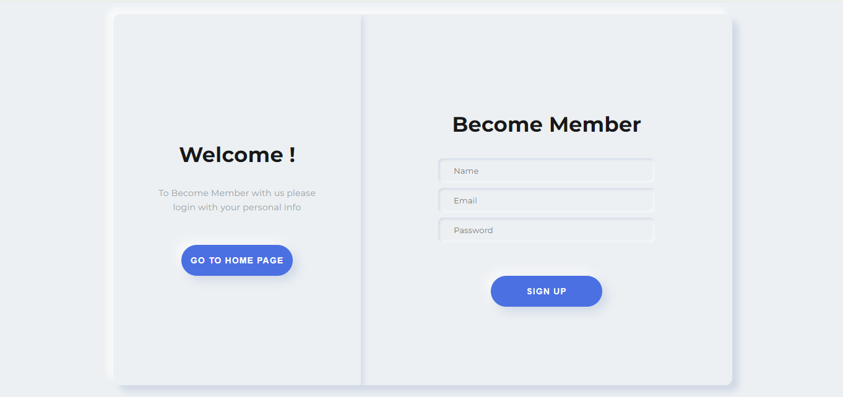

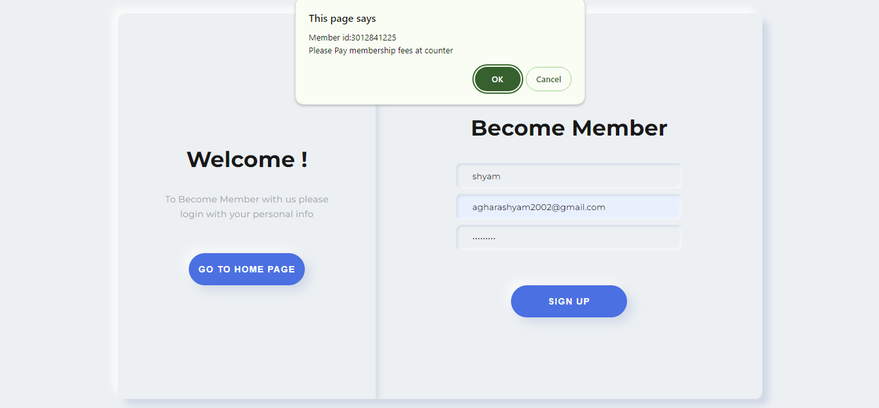

Food page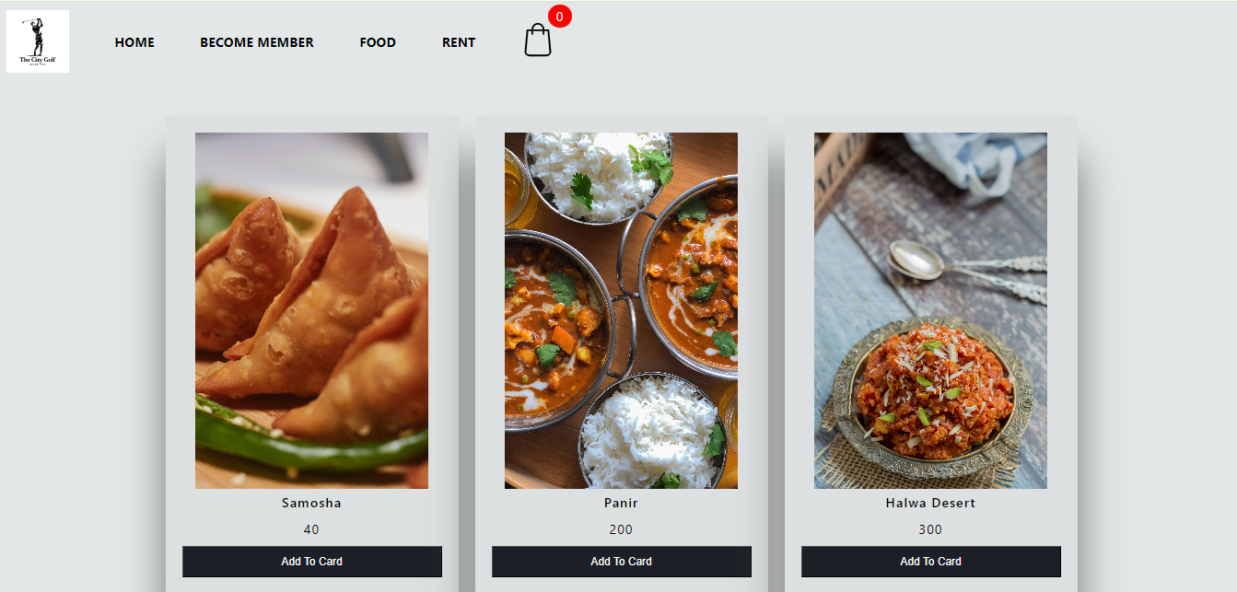

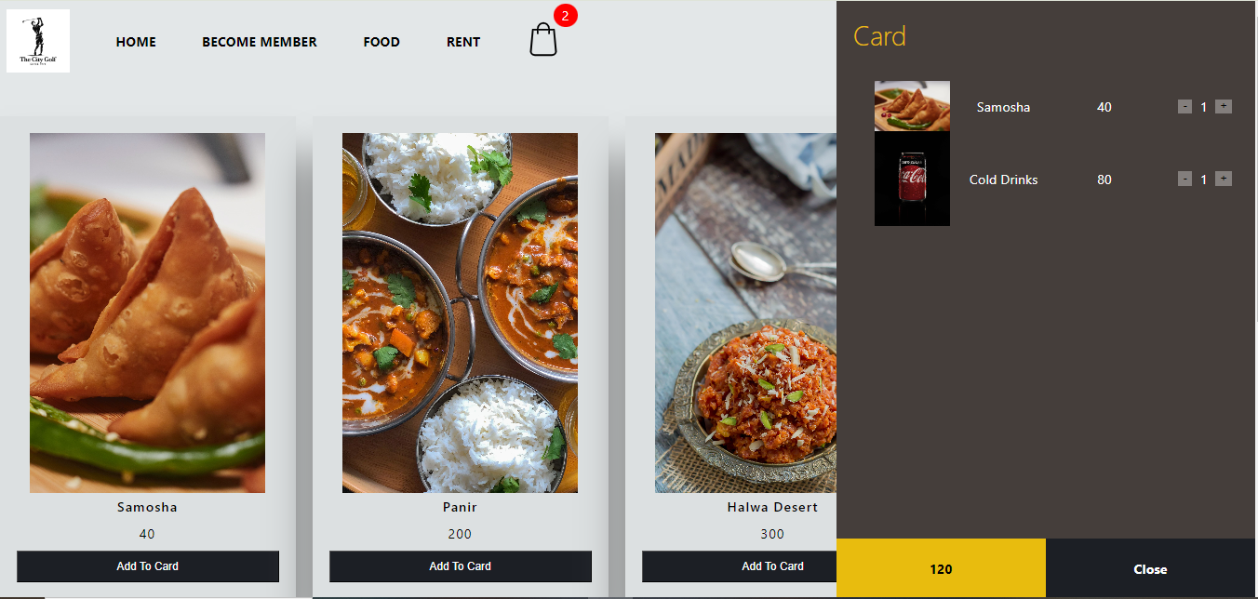

Rent-Buy page

